College of Micronesia - FSM



Fact book

2013

Office of Institutional Research and Planning
rschplanning@comfsm.fm

President and Chief Executive Officer
Joseph M. Daisy, Ed.D.

Board of Regents
Kasio E. Mida, Chairman (National Government)
Lyndon Cornelius, Vice Chairman (Kosrae State)
Mary B. Figir, Secretary/Treasurer (Yap State)
Graceful Enlet, Member (Chuuk State)
Churchill Edward, Member (Pohnpei State)

Department Heads
Mariana Ben Dereas, Vice President for Instructional Affairs
Joey Oducado, Acting Vice President for Student Services
Joe Habuchmai, Vice President for Administrative Services
Jim Currie, Vice President for Cooperative Research and Extension
Frankie Harris, Vice President for Institutional Effectiveness and Quality Assurance

Campus Deans
Kind Kanto, Chuuk Campus Dean
Kalwin Kephas, Kosrae Campus Dean
Grilly Jack, Acting Pohnpei Campus Dean
Lourdes Roboman, Yap Campus Dean

Contact Information (website: www.comfsm.fm)

National Campus  College of Micronesia – FSM  P.O. Box 159  Kolonia, Pohnpei, FM 96941  Phone: (691) 320-2480  Fax: (691) 320-2479  Email: national@comfsm.fm | Chuuk State Campus  College of Micronesia-FSM  P.O. Box 879  Chuuk, FM 96942Phone: (691)330-2689  Fax: (691)330-2740  E-Mail: chuuk@comfsm.fm | FMI Fisheries and Maritime Institution  College of Micronesia-FSM  P.O. Box 1056  Colonia Yap, FM 96943  Phone: (691)350-(691)3544  Fax: (691)350-(691)3545  E-Mail:  fmi@comfsm.fm
Kosrae State Campus  College of Micronesia-FSM  P.O. Box 37  Tofol Kosrae, FM 96944Phone: (691)370-3191  Fax:  (691)370-3193  E-Mail: kosrae@comfsm.fm | Pohnpei State Campus  College of Micronesia-FSM  P.O. Box 614  Kolonia Pohnpei, FM 96941Phone: (691)320-(691)3795  Fax: (691)320-(691)3799  E-Mail: pohnpei@comfsm.fm | Yap State Campus  College of Micronesia-FSM  P.O. Box 286  Colonia Yap, FM 96943Phone: (691)350-2296/5149  Fax: (691)350-5150  E-Mail: yap@comfsm.fm

Table of Contents
Introduction 1
Composition of the Fact Book 1
Student Enrollment 2
Credits 5
Student Achievement 7
Academic Standing 7
Course Completion Rates 8
Retention Rates 8
Degrees Awarded and Graduation Rates 9
Degrees Awarded 9
Graduation Rates 11
Spring Semester 12
Summer Semester 13
Personnel 13
Financial Aid 14
FSM Census and School Enrollment Data 14

Figure 1 Fall Enrollment 2004 - 2012 2
Figure 2 Fall Headcount vs FTE 3
Figure 3 Fall Enrollment by Campus 3
Figure 4 Fall Enrollment by Student Type 4
Figure 5 Fall Enrollment by Degree Type 4
Figure 6 Fall Enrollment by State of Origin 5
Figure 7 Fall Total Credits 5
Figure 8 Fall total Credits by Campus 6
Figure 9 Fall Average Credits by Campus 6
Figure 10 Fall Enrollment by Gender 7
Figure 11 Fall Students in Good Academic Standing 7
Figure 12 Fall Course Completion Rates 8
Figure 13 Fall Retention Rates 8
Figure 14 Degrees and Certificates Awarded by Academic Year 9
Figure 15 Graduates by Degree Type 10
Figure 16 Graduates by Gender 10
Figure 17 Graduates by State of Origin 11
Figure 18 Graduation Rates 11
Figure 19 Spring Enrollment Data 12
Figure 20 Spring Credit Data 12
Figure 21 Summer Enrollment and Credits 13
Figure 22 Personnel Count and Citizenship 13
Figure 23 Percent of Students Eligible for Pell Grant 14
Figure 24 FSM Population Data 14
Figure 25 FSM Population Pyramid and K - 12 Enrollment 15

Table 1 Fall 2012 Enrollment by Major 16
Table 2 Graduates by Academic Year and Major 17

Introduction

The College of Micronesia – FSM (COM-FSM) is a two year, English language speaking institution of higher education located in the Federated States of Micronesia (FSM), a small island developing nation located in the western Pacific Ocean. COM-FSM is composed of a national campus located in Palikir, Pohnpei, state campuses in each of the FSM states (Chuuk, Kosrae, Pohnpei and Yap) and a FSM Fisheries Maritime Institute located in Yap State. The central administrative are located at the national campus. The following figure shows the FSM’s relative location western Pacific Ocean and details of the States and islands composing the FSM.
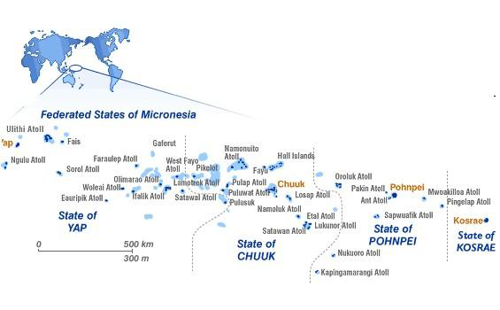

The college is accredited by the Accrediting Commission for Community and Junior Colleges (ACCJC), of the Western Association of Schools and Colleges (WASC).

Composition of the Fact Book

This Fact Book primarily focuses on Fall Semester data from 2008 – 2012 to coincide with key data and definitions from the U.S. Department of Education’s Integrated Postsecondary Education Data System (IPEDS). Summary information is also provided for spring and summer semesters. Focus is on student enrollment and achievement information with additional information on human resources and budget. As COM-FSM primarily serves the FSM, recent census and K-12 enrollment data is included.

Information in the Fact Book is presented in graphical format, with detailed tables for enrollment by majors and information on graduates included at the end. Additional information on enrollment and student achievement is available on the college web site. Sources of information for enrollment and students achievement are extracts from the college’s Student Information system (SIS). Data on human resources is provided by the of the college’s Office of Human Resources, budget information’s from the FSM Budget Preparation System (BPS) and FSM census information from the FSM Office of Statistics. For additional information or comments contact the Office of Institutional Research and Planning (IPRO) at rschplanning@comfsm.fm.

Student Enrollment

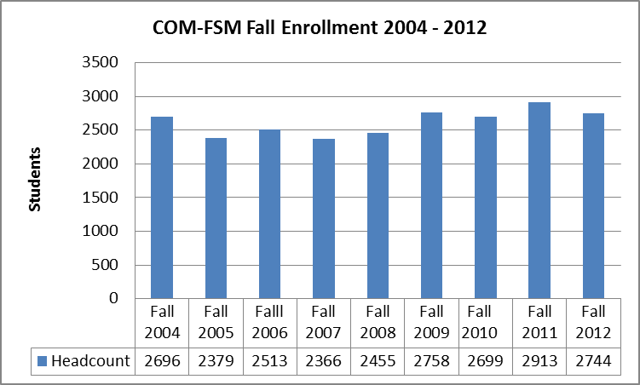
Figure 1 Fall Enrollment 2004 - 2012

Between fall 2004 and fall 2012 the college’s student enrollment has varied from a low of 2379 during fall 2005 to a high of 2913 during fall 2011. Lower enrollment in fall 2005 – 2008 were impacted by a teach out at Chuuk campus pending facilities repair to a high of 2913 in fall 2011 coinciding with final period of the year-round Pell awards.

Figure 2 Fall Headcount vs FTE

Full Time Equivalence (FTE) has generalled lagged behind headcount by 2% to 5%. Fall Semester 2010 was the exception where FTE enrollment exceeded headcount.

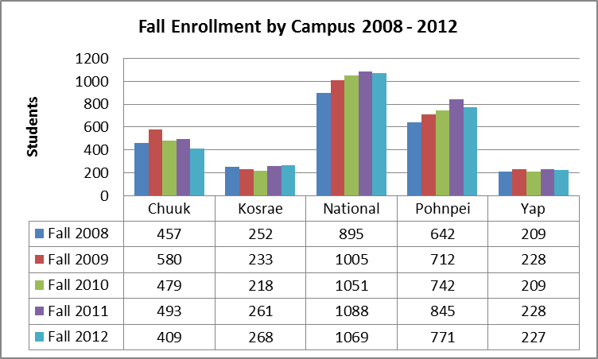
Figure 3 Fall Enrollment by Campus
Fall enrollment by campus have seen general trends for increased enrollments at the National and Pohnpei campuses with Kosrae and Yap campuses somewhat stable. Chuuk campus has seen a decline in overall enrollment.

Figure 4 Fall Enrollment by Student Type

There has been a decline of 9.3% in the overall percentage of new students to the overall student population of the college from fall 2008 to fall 2012. Returning students represented 4.4% of the student population in fall 2012 compared to no returning students fall 2004, 2006, and 2007.

Figure 5 Fall Enrollment by Degree Type

Fall enrollment by degree types have been impacted by a redesign of developmental education programs. An Achieving College Excellence (ACE) program allows selected students to enroll in degree programs while completing development course work. The net result has been a decrease in students classified as certificate students and an increase in associates of arts. Changes in the Third Year Certificate program are primarily attributed to changes in Pell grant eligibility requirements.

Figure 6 Fall Enrollment by State of Origin

In fall 2012 Pohnpeians represented 56.2% all students, up from 52.7% in fall 2008. Kosraean’s and Yapese have been fairly constant at approximately 12%, but Chuukese have decline from 22.9% in fall 2008 to 18.2% in fall 2012.

Credits

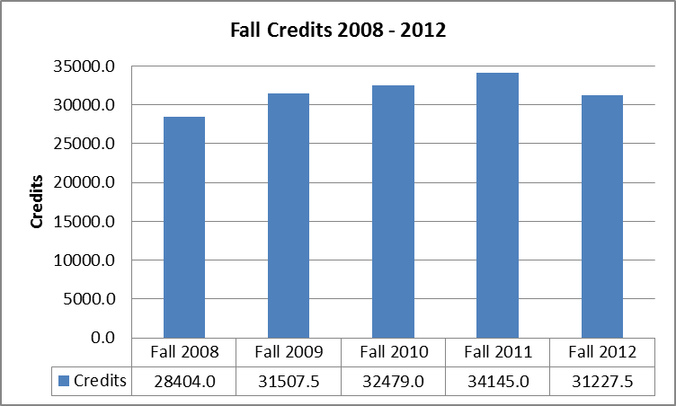
Figure 7 Fall Total Credits

Total credits from fall 2008 to fall 2012 have varied by approximately 17%. Fall 2012 total credits are near the 31,552 credits average for the five semesters.

Figure 8 Fall total Credits by Campus

Credits at the National Campus in fall 2012 represented 42% of all credits at the college followed by Pohnpei Campus at 25.8%, Chuuk Campus at 16.2%, Kosrae Campus at 8.2% and Yap Campus at 7.8%.

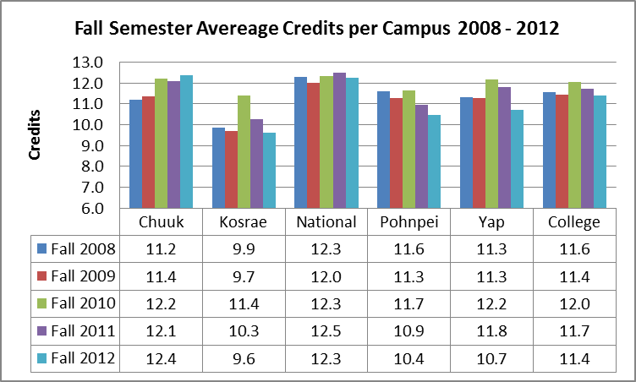
Figure 9 Fall Average Credits by Campus

Average credits per campus have seen the National Campus steady at 12 credits per student or above. Chuuk Campus has seen a generally steady increase in average credits while Pohnpei Campus average credits have declined over the 5 year period. Kosrae Campus has generally had the fewest average credits per student.

Figure 10 Fall Enrollment by Gender

Females are representing 53% to 54% of the overall student population between fall 2008 and fall 2012.

Student Achievement

Academic Standing

Figure 11 Fall Students in Good Academic Standing

The percent of students in good academic standing (a GPA of 2.00 or greater) has seen an increase from 72% in fall 2004 to the current rate of 79% in fall 2012.

Course Completion Rates

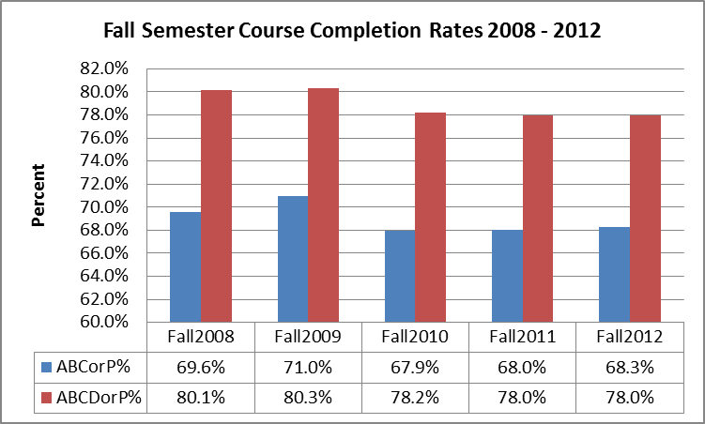
Figure 12 Fall Course Completion Rates

Course completions rates for both grades A, B, C, and P (passing); and grades A, B, C, D, or P (passing) have been fairly consistent with only a slight decline from fall 2008 to fall 2012. Course completion rates are presented for both ABC or P grades and ABCD or P grades as the college catalogue defines passing as ABCD or P, but a number of course require a C grade or better to earn credit and proceed to the next level.

Retention Rates

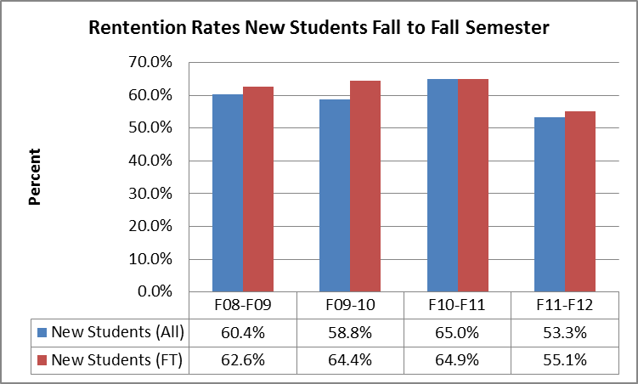
Figure 13 Fall Retention Rates

Retention rates are currently at 53.3% for all students from the new student cohort for fall 2011 and 55.1% for full time students.

Degrees Awarded and Graduation Rates

Degrees Awarded

Figure 14 Degrees and Certificates Awarded by Academic Year

Total number of degrees and certificates awarded has increased by 68% from AY2008/02 to AY2011/12.

Figure 15 Graduates by Degree Type

Increases in certifies and degrees awarded have been seen in all certificate and degree types.

Figure 16 Graduates by Gender

In AY2008/09 there were more males than female graduates, but by AY2011/12 females represented 60% of all graduates at the college.

Figure 17 Graduates by State of Origin

In terms of the percent of graduates by state of origin, Pohnpeian’s have increased from 48.6% of overall awards in AY2008/09 to 60% in AY2011/12.

Graduation Rates

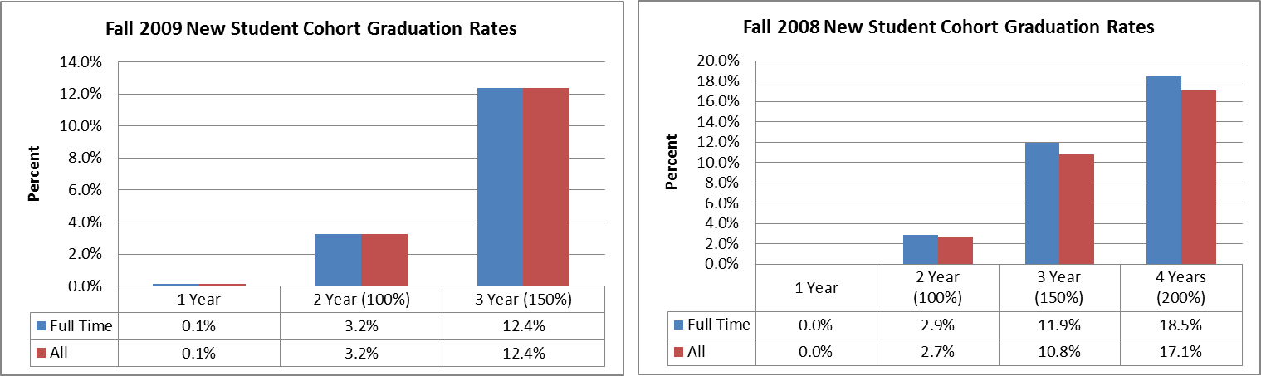
Figure 18 Graduation Rates
Graduation rates are lagging indicators. The rates are determined by taking new student cohorts in fall semesters and tracking the number of first time graduates at specified times related to the recommended time of completion for the program. The data above is presented for both new students who were full time (took 12 or more credits in the initial fall semester) all new students. For a certificate degree, the recommended time for completion is one year. For associates programs, the recommended time for completion is two years. For IPEDS, graduation rates are reported for 100% of time (2 years), 150% of time (3 years) and 200% of time (4 years). There is a slight increase in 3 year graduation rates. Students from the fall cohorts of new students who earn more than one degree at the college are counted only for the first degree earned.

Spring Semester
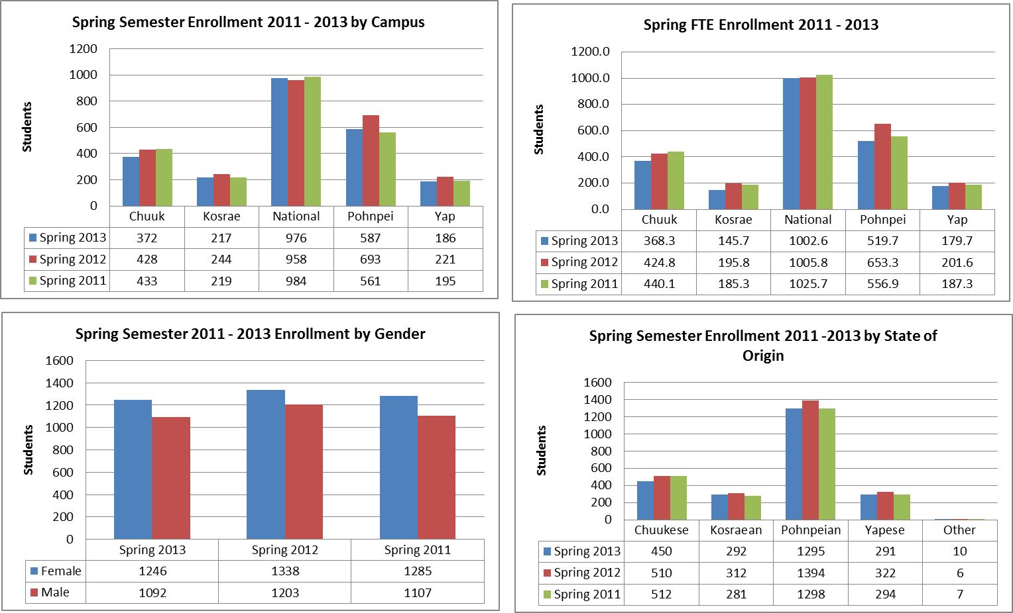
Figure 19 Spring Enrollment Data

The four charts above show enrollment data for spring semester 2011 – 2013. There tends to be less variation in spring enrollment data compared to fall semester data. Total spring enrollment was 2338 (2013), 2544 (2012) and 2392 (2011).

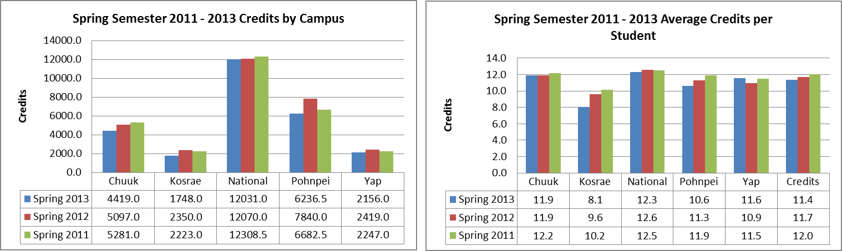
Figure 20 Spring Credit Data

As with fall semesters, there has been as sight decline (5%) in average credits taken per student over the past 3 semesters.

Summer Semester

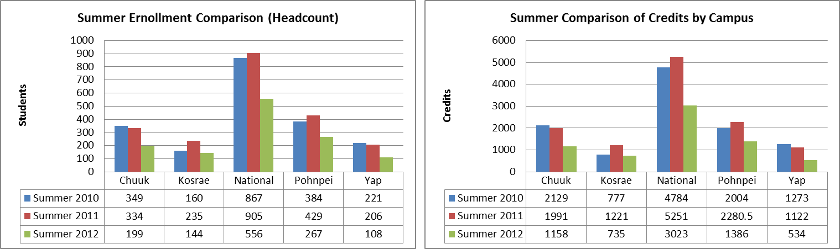
Figure 21 Summer Enrollment and Credits

A snapshot of summer semester data is shown above. Enrollment during summer semesters has been impacted by the Pell grant availability. During the summers of 2010 & 2011, students were eligible for and took advantage of the year-round Pell awards.

Personnel

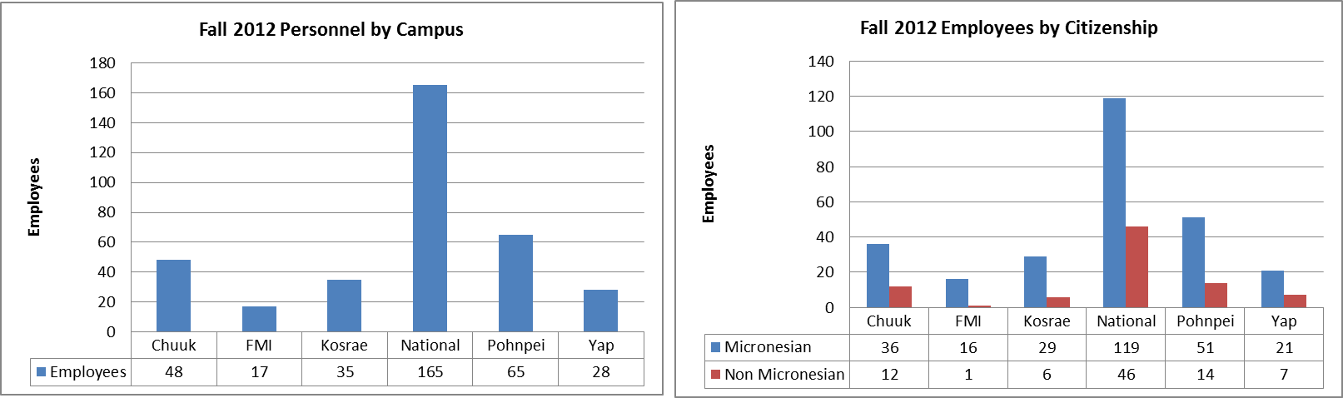
Figure 22 Personnel Count and Citizenship

Human resources are primarily concentrated at the national campus where offices provide services to the National Campus and state campuses. Overall, Micronesians represent 76% of the college workforce. Expatriates represented 16 different countries in fall 2012.

Financial Aid

Figure 23 Percent of Students Eligible for Pell Grant
Pell grant awards to students cover the main part of tuition and fees. The percent of students eligible for Pell grant by campus tend to range from the low 90s to the mid 80s.

FSM Census and School Enrollment Data

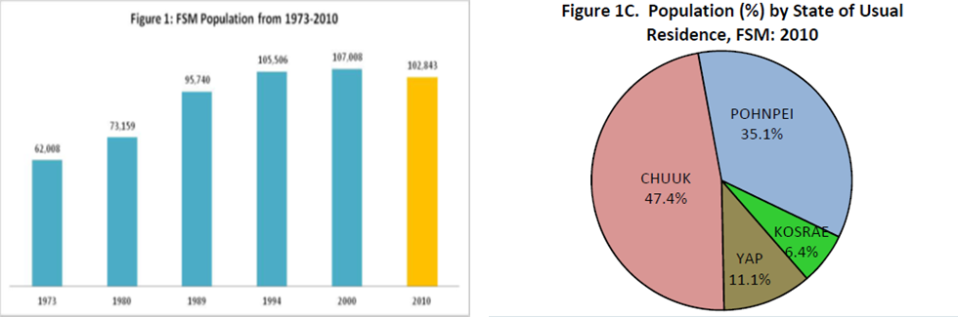
Figure 24 FSM Population Data

From 1975 to 1994 the FSM population was in a steady increase. Beginning with the 2000 census a slowing of the increase was observed, with the 2010 census showing a decline in overall FSM population. Additional, the current (2010) median age is at 21.5 years, a significant increase from the 18.9 in 2000. The pie chart of percentage of population by state can be used for comparison with student state of origin data.

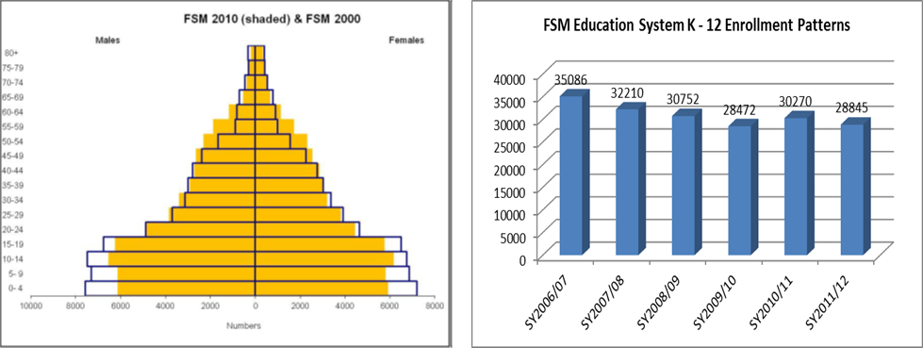
Figure 25 FSM Population Pyramid and K - 12 Enrollment

The FSM’s population pyramid is showing reductions in the age groups for 0-4, 5-9, 10-14, and 15-19 from the 2000 to the 2010 census. Data from the FSM National Department of Education shows declining enrollment trends for K – 12.

Table 1 Fall 2012 Enrollment by Major
majorDescription | degree | Chuuk | Kosrae | National |  | Pohnpei |  | Yap |  | College |  | %
Health Career Opportunities Program | AA |  | 7 | 107 | 13 |  | 14 |  | 141 |  | 5.1%
Liberal Arts | AA |  | 59 | 188 | 44 |  | 33 |  | 324 |  | 11.8%
Micronesian Studies | AA |  | 5 | 96 | 21 |  | 3 |  | 125 |  | 4.6%
Teacher Preparation | AA | 211 | 31 | 139 | 21 |  | 37 |  | 439 |  | 16.0%
Building Technology | AAS |  |  |  | 34 |  |  |  | 34 |  | 1.2%
Electronics Technology | AAS |  | 27 |  | 60 |  |  |  | 87 |  | 3.2%
Telecommunications | AAS |  |  |  | 63 |  |  |  | 63 |  | 2.3%
Ag. & Nat. Res. Management | AS |  | 1 | 23 | 18 |  | 2 |  | 44 |  | 1.6%
Agriculture | AS |  |  | 6 |  |  |  |  | 6 |  | 0.2%
Business Administration | AS | 35 | 15 | 149 | 26 |  | 17 |  | 242 |  | 8.8%
Computer Information Systems | AS |  | 5 | 156 | 20 |  | 32 |  | 213 |  | 7.8%
Hospitality and Tourism Management | AS |  |  | 7 | 62 |  | 2 |  | 71 |  | 2.6%
Marine Science | AS |  | 15 | 46 | 9 |  | 1 |  | 71 |  | 2.6%
Nursing | AS | 1 | 11 | 25 |  |  | 2 |  | 39 |  | 1.4%
Public Health | AS |  | 6 | 17 | 1 |  |  |  | 24 |  | 0.9%
Teacher Education - Elementary | AS | 11 | 1 |  |  |  |  |  | 12 |  | 0.4%
Elementary Education | BA |  |  | 43 |  |  |  |  | 43 |  | 1.6%
Agriculture and Food Technology | CA |  | 27 |  | 97 |  | 21 |  | 145 |  | 5.3%
Basic Public Health | CA | 1 | 34 | 1 |  |  |  |  | 36 |  | 1.3%
Bookkeeping | CA | 124 |  |  | 86 |  | 8 |  | 218 |  | 7.9%
Building Maintenance and Repair | CA |  |  |  | 19 |  |  |  | 19 |  | 0.7%
Cabinet Making/Furniture Making | CA |  |  |  | 32 |  |  |  | 32 |  | 1.2%
Career Education: Motor Vehicle Mechanic | CA |  |  |  | 15 |  |  |  | 15 |  | 0.5%
Carpentry | CA |  | 2 |  | 14 |  |  |  | 16 |  | 0.6%
Construction Electricity | CA |  |  |  | 20 |  |  |  | 20 |  | 0.7%
Electronic Engineering Technology | CA |  | 22 |  | 32 |  | 25 |  | 79 |  | 2.9%
Health Assistant Training Program | CA |  |  |  |  |  | 17 |  | 17 |  | 0.6%
Law Enforcement | CA |  |  |  | 2 |  |  |  | 2 |  | 0.1%
Nursing Assistant | CA |  |  | 1 |  |  | 1 |  | 2 |  | 0.1%
Refrigerator and Air Conditioning | CA |  |  |  | 24 |  |  |  | 24 |  | 0.9%
Secretarial Science | CA | 26 |  |  | 37 |  | 4 |  | 67 |  | 2.4%
Trial Counselor | CA |  |  | 19 |  |  | 5 |  | 24 |  | 0.9%
Public Health | TYC |  |  | 11 |  |  |  |  | 11 |  | 0.4%
Teacher Preparation - Elementary | TYC |  |  | 33 |  |  |  |  | 33 |  | 1.2%
Unclassified | UC |  |  | 2 |  |  | 3 |  | 5 |  | 0.2%
Undeclared | UD |  |  |  | 1 |  |  |  | 1 |  | 0.0%
Total |  | 409 | 268 | 1069 | 771 |  | 227 |  | 2744 |  | 100.0%

Table 2 Graduates by Academic Year and Major
majorDescription | degree | AY2008/09 | AY2009/10 | AY2010/11 | AY2011/12 | Total4Year
Liberal Arts | AA | 54 | 53 | 67 | 46 | 220
Teacher Education - Elementary | AS | 48 | 57 | 67 | 34 | 206
Business Administration | AS | 20 | 27 | 35 | 33 | 115
Teacher Preparation - Elementary | TYC | 20 | 18 | 20 | 51 | 109
Computer Information Systems | AS | 19 | 34 | 21 | 33 | 107
Teacher Preparation | AA | 14 | 8 | 22 | 48 | 92
Micronesian Studies | AA | 10 | 26 | 33 | 20 | 89
Health Career Opportunities Program | AA | 18 | 15 | 17 | 35 | 85
General Studies | CA | 10 | 25 | 17 | 1 | 53
Agriculture and Food Technology | CA | 2 | 7 | 10 | 15 | 34
Marine Science | AS | 1 | 9 | 11 | 12 | 33
Trial Counselor | CA | 5 | 3 | 10 | 13 | 31
Electronics Technology | AAS | 5 | 6 | 6 | 12 | 29
Hospitality and Tourism Management | AS | 3 | 11 | 4 | 10 | 28
Building Technology | AAS | 3 | 5 | 10 | 3 | 21
General Business | TYC | 6 | 2 | 4 | 5 | 17
Bookkeeping | CA | 3 | 3 | 5 | 4 | 15
Nursing Assistant | CA |  |  |  | 12 | 12
Accounting | TYC |  | 4 | 5 | 3 | 12
Electronic Engineering Technology | CA | 2 |  | 4 | 3 | 9
Agriculture | AS | 2 |  | 3 | 3 | 8
Early Childhood Education | AS | 3 | 3 |  | 1 | 7
Building Maintenance and Repair | CA | 1 |  | 6 |  | 7
Public Health | TYC |  |  | 4 | 3 | 7
Telecommunications | AAS |  |  |  | 6 | 6
Construction Electricity | CA | 2 | 2 |  | 2 | 6
Career Education: Motor Vehicle Mechanic | CA |  |  | 2 | 3 | 5
Health Assistant Training Program | CA |  |  | 5 |  | 5
Telecommunication Technology | AAS |  | 2 | 2 |  | 4
Electronics Technology | ACA |  |  |  | 4 | 4
Public Health | AS |  |  |  | 4 | 4
Carpentry | CA | 1 | 2 |  | 1 | 4
Refrigerator and Air Conditioning | CA | 1 | 2 |  | 1 | 4
Accounting | AS | 1 |  | 1 | 1 | 3
Teacher Education - Elementary | TYC |  | 1 | 2 |  | 3
Liberal Arts / Media Studies | AA |  | 2 |  |  | 2
Ag. & Nat. Res. Management | AS |  |  |  | 2 | 2
Cabinet Making/Furniture Making | CA |  |  |  | 2 | 2
Education | AS |  |  |  | 1 | 1
Electronics Technology | CA | 1 |  |  |  | 1
Secretarial Science | CA |  |  |  | 1 | 1
Business Administration | TYC |  | 1 |  |  | 1
Graduates |  | 255 | 328 | 393 | 428 | 1404

FTE data is calculated by dividing the total number of credits by 12 credits (IPEDS definition of a full time student).
Retention rates are calculated based on new fall semester student cohort (both full time and all students) who returned to school the following fall semester

